QVision Mini Campaign
MAXQ Partner Marketing January 2011

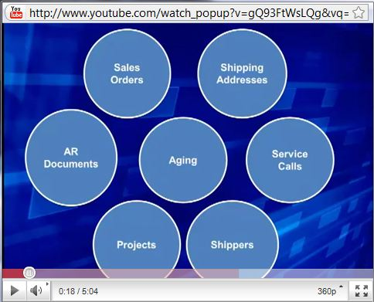
Email Copy
Subject: Productivity 101: Solutions for your Ever-Expanding To-Do list
Hi <NAME>,
We wanted to share with you an exciting product for Microsoft Dynamics users that can boost productivity and help you bring together data from one or many applications at price point that will make your boss smile.
Accessed through your web browser, you can have secure, role-based access to the data you need without having to request IT resources. No more importing, exporting, and de-duplicating spreadsheets - using QVision you can point and click your way to assemble or navigate the data you need so you can get through your ever-expanding to-do list faster.
It’s far easier to show you than tell you about how much more productive you can be with QVision. So take a quick 4 minute break - you deserve it! - And enjoy this entertaining not-so-conventional video which will give you a great overview of QVision.
If you like what you see and are interested in learning more - give us a call for a custom presentation.
**************************************************************************************************
Instructions:
- To post the video to a web page, use the html code below.
<object width="480" height="385"><param name="movie" value="http://www.youtube.com/v/gQ93FtWsLQg?fs=1&amp;hl=en_US&amp;rel=0&amp;color1=0x2b405b&amp;color2=0x6b8ab6"></param><param name="allowFullScreen" value="true"></param><param name="allowscriptaccess" value="always"></param><embed src="http://www.youtube.com/v/gQ93FtWsLQg?fs=1&amp;hl=en_US&amp;rel=0&amp;color1=0x2b405b&amp;color2=0x6b8ab6" type="application/x-shockwave-flash" allowscriptaccess="always" allowfullscreen="true" width="480" height="385"></embed></object>
- Be sure to link the URL of the web page where you’ve placed the above code into the copy of your email and to the image in the email.

